1. Enable all IIS options



1. Install AccessDatabaseEngine_x64.exe
2. Change the .net framework version to 4.0



1. Change the .net framework version of DefaultApplicationPool:



1. Open advanced setting for DefaultApplicationPool



1. Set Enabled 32-bit applications to true

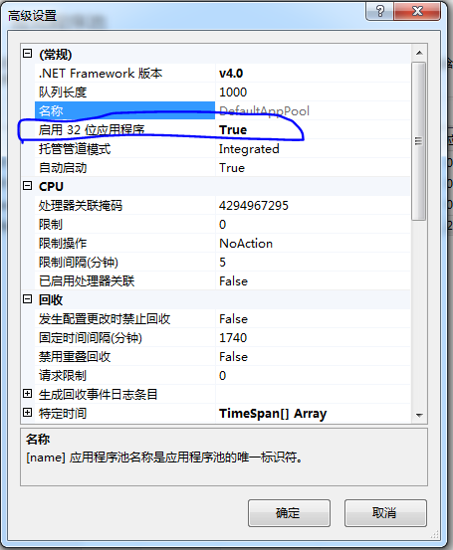

If put the mdb file in C driver, maybe the default setting will deny the modification. Need to add rights for the directory that contain the physical contents of the website. The default is : C:\inetpub\wwwroot\AssetMan

